**Industrial Internship Report on**

**URL Shortener**

**Prepared by**

**LOKAN GAHIR**

|  |
| --- |
| *Executive Summary* |
| This report provides details of the Industrial Internship provided by upskill Campus and The IoT Academy in collaboration with Industrial Partner UniConverge Technologies Pvt Ltd (UCT).  This internship was focused on a project/problem statement provided by UCT. We had to finish the project including the report in 6 weeks’ time.  My project was the URL shortener project involves creating a tool that takes long URLs and generates shorter, more manageable versions. The project typically includes backend development tasks such as implementing a URL shortening algorithm, integrating a database for storing URLs, and creating API endpoints for handling shortening requests and redirection. Frontend development, including a user interface and input validation, is optional but can enhance the user experience. Deployment involves hosting the application on a web server and implementing security measures. Overall, the project provides a practical and hands-on experience in solving real-world problems in the realm of web development and data management.  This internship gave me a very good opportunity to get exposure to Industrial problems and design/implement solution for that. It was an overall great experience to have this internship. |

**TABLE OF CONTENTS**

1 Preface 3

2 Introduction 8

2.1 About UniConverge Technologies Pvt Ltd 8

2.2 About upskill Campus 12

2.3 The IOT Academy 13

2.4 Objective 13

2.5 Reference 13

2.6 Glossary 14

3 Problem Statement 15

4 Existing and Proposed solution 17

5 Proposed Design/ Model 20

5.1 High Level Diagram (if applicable) 21

6 Performance Test 22

6.1 Test Plan/ Test Cases 23

6.2 Test Procedure 24

6.3 Performance Outcome 26

7 My learnings 28

8 Future work scope 29

# Preface

**Summary of the whole 6 weeks’ work:**

During the first week of the internship, I selected the URL shortener project as my focus. I researched and identified the key components and requirements for the project.

In the second week, I proposed a design for the URL shortener. This included outlining the architecture, database structure, and user interface. I also created pseudo code to help guide the implementation process.

Moving into the third week, I started implementing the design. I began by setting up the necessary frameworks and libraries. I created the database structure and implemented the URL shortening algorithm. I also worked on the API endpoints for handling URL shortening requests.

Continuing into the fourth week, I focused on further implementing the design. I integrated the database functionality into the application, allowing for the storage and retrieval of URLs. I worked on improving the user interface and enhancing the user experience.

By the fifth week, I shifted my attention towards checking the performance of the URL shortener. I conducted tests to evaluate the speed and efficiency of the system. I optimized the code and made any necessary improvements to enhance the performance.

During the final week of the internship, I focused on ensuring the quality of the URL shortener project. I performed thorough testing, including unit tests and user testing, to identify and fix any bugs or issues. I also worked on refining the user interface and adding any additional features or functionality as needed. Finally, I compiled all the documentation and completed the final report, including a summary of the project, its implementation, and any recommendations or future enhancements.

At the end of the internship, I submitted the final report, showcasing the progress made throughout the six weeks and providing a comprehensive overview of the URL shortener project.

**About need of relevant Internship in career development:**

Relevant internships play a crucial role in career development for several reasons:

**1. Practical Experience:** Internships provide an opportunity to gain practical, hands-on experience in a specific field or industry. They allow you to apply the theoretical knowledge you've acquired in a real-world setting, helping you develop a deeper understanding of the work involved and the skills required.

**2. Skill Development:** Internships offer a platform to enhance and develop valuable skills that are relevant to your desired career path. You can learn industry-specific tools, technologies, and best practices, as well as develop transferable skills such as communication, teamwork, problem-solving, and time management.

**3. Industry Exposure:** Internships provide an insider's view of the industry or profession you're interested in. You can gain exposure to the day-to-day operations, company culture, and industry trends. This exposure helps you make informed decisions about your career path and can guide your future choices.

**4. Networking Opportunities:** Internships allow you to connect and network with professionals in your chosen field. Building relationships with mentors, colleagues, and industry experts can open doors to future job opportunities and provide valuable guidance and advice.

**5. Resume Building:** Having relevant internship experience on your resume demonstrates to potential employers that you have practical experience in the field and are proactive in your professional development. It can make your resume stand out and increase your chances of securing future employment.

**6. Clarifying Career Goals:** Internships can help you explore different areas within a specific field, giving you a clearer understanding of your interests and strengths. They allow you to test the waters and gain insight into whether a particular career path aligns with your goals and aspirations.

Overall, relevant internships provide a valuable platform for career development by offering practical experience, skill development, industry exposure, networking opportunities, resume building, clarity of career goals, and professional growth. They serve as a bridge between academic learning and professional employment, allowing you to make informed decisions about your future career path.

**Brief about Your project/problem statement:**

As an AI language model, I don't have personal projects or problem statements. However, I can assist you with understanding and formulating a problem statement for your project.

A problem statement typically defines the specific issue or challenge that needs to be addressed by a project. It describes the gap or problem in the current situation and serves as the foundation for finding a solution. To create a problem statement for your project, consider the following steps:

**1. Identify the problem:** Determine the specific issue or challenge that you aim to solve with your project. For example, in the case of a URL shortener project, the problem could be the need for a tool to make long URLs more manageable and shareable.

**2. Define the scope:** Clearly define the boundaries of the problem and the scope of your project. This helps to ensure that the problem statement is focused and achievable within the given time frame and resources.

**3. Consider stakeholders:** Identify the stakeholders who are affected by or have an interest in the problem. For a URL shortener project, stakeholders may include users who need to share URLs, businesses that rely on efficient link sharing, and developers who want to integrate URL shortening functionality into their applications.

**4. Specify the desired outcome:** Determine the expected outcome or solution that will address the identified problem. In the case of a URL shortener project, the desired outcome could be a tool that generates shortened URLs, stores them in a database, and redirects users to the original URLs when clicked.

**5. Formulate the problem statement:** Combine all the above information into a clear and concise problem statement. It should describe the problem, its impact, and the desired outcome. For example, a problem statement for a URL shortener project could be: "The lack of a reliable and user-friendly URL shortening tool hinders efficient sharing of long URLs, leading to decreased accessibility and difficulty in tracking link analytics. The project aims to develop a URL shortener application that generates shortened URLs, stores them securely, and seamlessly redirects users to the original URLs.

Remember that the problem statement serves as a guide for your project and helps you stay focused on addressing the specific issue at hand. It provides clarity to both yourself and others involved in the project about the problem and the intended solution.

**Opportunity given by USC/UCT:**

Upskill Campus (USC) or The IoT Academy in collaboration with UniConverge Technologies Pvt Ltd (UCT) as of my knowledge cutoff in September 2021, internships and collaborations with industry partners generally offer valuable opportunities for professional growth and development.

Participating in an internship or collaboration program with USC/UCT could provide the following opportunities:

**1. Industry Exposure:** Working with a renowned institution and industry partner gives you exposure to real-world industrial problems, challenges, and practices. It allows you to gain insights into the operations and dynamics of the industry, which can be invaluable for your career.

**2. Practical Experience:** Internships and collaborations offer hands-on experience, enabling you to apply your knowledge and skills in a practical setting. Working on projects or problem statements provided by industry partners helps bridge the gap between theory and practice, enhancing your understanding and proficiency in your chosen field.

**3. Networking:** Collaborating with USC, UCT, and their industry partner gives you the opportunity to build a professional network. You can connect with professionals, mentors, and experts in the industry, which can lead to future job prospects, references, and valuable connections.

**4. Skill Development:** Engaging in projects and problem-solving within the context of an internship or collaboration provides an avenue for skill development.

**How Program was planned:**

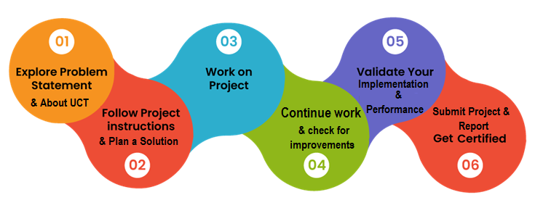

**Learnings and overall experience:**

Learnings and overall experience you might expect from working on a URL shortener project during a Python internship.

**1. Technical Skills:** Working on a URL shortener project in Python allows you to enhance your technical skills in various areas. You'll gain proficiency in Python programming.

**2. Problem-Solving:** Developing a URL shortener involves addressing specific challenges, such as generating unique shortened URLs, managing the database, and implementing the redirection mechanism. Throughout the project, you'll enhance your problem-solving skills by identifying and implementing effective solutions to these challenges.

**3. Project Management:** Participating in an internship project like a URL shortener involves managing your time and tasks effectively. You'll gain experience in project planning, task prioritization, and meeting deadlines. Additionally, you may work collaboratively with a team or receive guidance from mentors, providing an opportunity to improve your communication and teamwork skills.

**4. Debugging and Testing:** During the implementation phase, you'll encounter and overcome challenges through debugging and testing. This process will enhance your troubleshooting skills and help you develop strategies for identifying and resolving issues in your code.

**5. Exposure to Industry Practices:** Internships often provide exposure to industry practices and standards. You may learn about coding conventions, version control systems (such as Git), code documentation, and collaborative development workflows. These experiences will help you align your skills and practices with industry expectations.

Overall, working on a URL shortener project during a Python internship offers a valuable opportunity to apply your programming knowledge to a practical, real-world scenario. It enables you to develop technical skills, problem-solving abilities, project management capabilities, and an understanding of industry practices. Remember to seek guidance from your mentors, collaborate with your peers, and make the most of the learning experience throughout the internship.

Thanks to Upskill Campus (USC) or The IoT Academy in collaboration with UniConverge Technologies Pvt Ltd (UCT) for this Internship Oppurtinity.

# Introduction

## About UniConverge Technologies Pvt Ltd

A company established in 2013 and working in Digital Transformation domain and providing Industrial solutions with prime focus on sustainability and RoI.

For developing its products and solutions it is leveraging various**Cutting Edge Technologies e.g. Internet of Things (IoT), Cyber Security, Cloud computing (AWS, Azure), Machine Learning, Communication Technologies (4G/5G/LoRaWAN), Java Full Stack, Python, Front end**etc.



1. UCT IoT Platform**(****)**

**UCT Insight** is an IOT platform designed for quick deployment of IOT applications on the same time providing valuable “insight” for your process/business. It has been built in Java for backend and ReactJS for Front end. It has support for MySQL and various NoSql Databases.

* It enables device connectivity via industry standard IoT protocols - MQTT, CoAP, HTTP, Modbus TCP, OPC UA
* It supports both cloud and on-premises deployments.

It has features to  
• Build Your own dashboard  
• Analytics and Reporting  
• Alert and Notification  
• Integration with third party application(Power BI, SAP, ERP)  
• Rule Engine





1. **Smart Factory Platform (****)**

Factory watch is a platform for smart factory needs.

It provides Users/ Factory

* with a scalable solution for their Production and asset monitoring
* OEE and predictive maintenance solution scaling up to digital twin for your assets.
* to unleased the true potential of the data that their machines are generating and helps to identify the KPIs and also improve them.
* A modular architecture that allows users to choose the service that they what to start and then can scale to more complex solutions as per their demands.

Its unique SaaS model helps users to save time, cost and money.





1. based Solution

UCT is one of the early adopters of LoRAWANteschnology and providing solution in Agritech, Smart cities, Industrial Monitoring, Smart Street Light, Smart Water/ Gas/ Electricity metering solutions etc.

1. Predictive Maintenance

UCT is providing Industrial Machine health monitoring and Predictive maintenance solution leveraging Embedded system, Industrial IoT and Machine Learning Technologies by finding Remaining useful life time of various Machines used in production process.



## About upskill Campus (USC)

upskill Campus along with The IoT Academy and in association with Uniconverge technologies has facilitated the smooth execution of the complete internship process.

USC is a career development platform that delivers **personalized executive coaching** in a more affordable, scalable and measurable way.



Seeing need of upskilling in self paced manner along-with additional support services e.g. Internship, projects, interaction with Industry experts, Career growth Services

upSkill Campus aiming to upskill 1 million learners in next 5 year

<https://www.upskillcampus.com/>

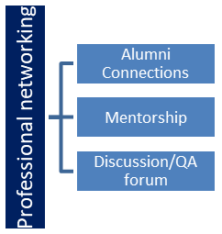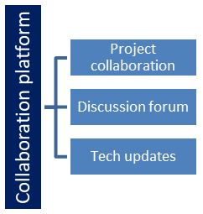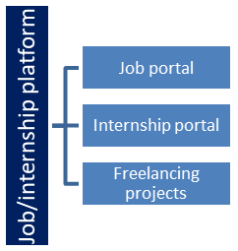

## The IoT Academy

The IoT academy is EdTech Division of UCT that is running long executive certification programs in collaboration with EICT Academy, IITK, IITR and IITG in multiple domains.

## Objectives of this Internship program

The objective for this internship program was to

 ☛ get practical experience of working in the industry.

 ☛ to solve real world problems.

 ☛ to have improved job prospects.

 ☛to have Improved understanding of our field and its applications.

 ☛to have Personal growth like better communication and problem solving.

## Reference

[1]Bitly API: Bitly is a popular URL shortening service that provides an API for developers to integrate shortening and analytics features into their applications. You can find more information about their API documentation here:

<https://dev.bitly.com/docs/getting-started/authentication/>

[2] TinyURL: TinyURL is another well-known URL shortening service. Although they don't provide an official API, you can refer to their website and examine how they generate and redirect shortened URLs:

<https://tinyurl.com/>

[3] Open source URL Shortener Projects: If you're interested in exploring open-source implementations of URL shorteners, you can check out projects like YOURLS (<https://yourls.org/>) (<https://polrproject.org/>).

## Glossary

|  |  |
| --- | --- |
| Terms | Acronym |
| URL | Uniform Resource Locator - A web address that specifies the location of a resource on the internet. |
| Shortened URL | A compressed or abbreviated version of a URL that redirects to the original, longer URL when accessed. |
| Redirect | The process of automatically forwarding a user from one URL to another. In the context of URL shorteners, clicking on a shortened URL triggers a redirect to the original long URL |
| API | Application Programming Interface - A set of rules and protocols that allows different software applications to communicate with each other. APIs are often used in URL shorteners to handle URL shortening requests and redirection. |
| Backend | The server-side of a web application that processes requests, manages data, and handles the logic behind the scenes. In a URL shortener project, the backend code would handle generating shortened URLs, storing them, and managing the redirection process. |

# Problem Statement:

Design and develop a URL shortener application using Tkinter, a Python GUI library. The application should provide a user-friendly interface for users to input long URLs and obtain shortened versions. The shortened URLs should redirect users to the original long URLs when clicked.

Certainly! The problem statement outlines the objectives and requirements for developing a URL shortener application using Tkinter. Let's break down the key components:

**1. User Interface:** The application should have a visually appealing and user-friendly interface created using Tkinter. It should include input fields for users to enter long URLs and display fields to show the corresponding shortened URLs.

**2. URL Shortening:** Implement an algorithm that takes a long URL as input and generates a unique shortened version. The algorithm should ensure that the shortened URLs are easy to remember and share.

**3. Database Integration:** Incorporate a database to store the original URLs and their shortened versions. When a user submits a long URL, the application should save the mapping in the database for future reference.

**4. Redirection:** Set up a mechanism that maps the shortened URLs to the original URLs. When a user clicks on a shortened URL, the application should retrieve the corresponding long URL from the database and redirect the user to the original URL.

**5. Copy to Clipboard:** Provide a feature that allows users to copy the shortened URL to the clipboard with a single click. This simplifies the process of sharing the shortened URL in other applications or platforms.

**6. Error Handling:** Implement robust error handling mechanisms to address potential issues such as invalid URLs or database connection errors. Inform users with appropriate error messages when necessary.

**7. User Experience:** Focus on creating a smooth and user-friendly experience. Consider adding features like progress indicators, clear status messages, and a responsive design to enhance usability and make the application intuitive for users.

**8. Testing and Documentation:** Thoroughly test the application to ensure it functions correctly and reliably. Document the project, including the design decisions, implementation details, and instructions for using the application.

By successfully developing this URL shortener application, you will create a tool that simplifies the process of sharing long URLs and improves accessibility. The application will have a visually pleasing interface, shorten URLs effectively, store the data in a database, provide redirection, enable easy copying to the clipboard, handle errors gracefully, and deliver an overall positive user experience.

# Existing and Proposed solution

Existing URL shortening solutions provided by various organizations and services have gained popularity and widespread usage. Here is a summary of some common solutions and their limitations:

**1. bit.ly:** Bit.ly is a well-known URL shortening service that offers a user-friendly interface, analytics, and custom short domain options. However, the limitations include dependency on the service provider, potential reliability issues if the service goes down, and limited control over the shortened URLs if the user wants to switch to a different service.

**2. TinyURL:** TinyURL is another popular URL shortening service that allows users to generate short links quickly. However, the main limitation is that the service does not offer advanced features such as custom domains or detailed analytics. Additionally, the service may not have the same level of scalability or availability as larger providers.

**Limitations of existing URL shortening solutions in general include:**

**- Dependency:** Relying on a third-party service for URL shortening means the availability and reliability of the service are beyond the user's control. If the service experiences downtime or discontinuation, it can disrupt the functionality of shortened URLs.

**- Privacy and Security:** Some URL shortening services may track user data, including IP addresses and browsing behavior. This raises privacy concerns, particularly if the shortened URLs are shared in sensitive contexts. Additionally, shortened URLs can potentially be manipulated to lead to malicious or harmful websites.

**- Link Longevity:** The lifespan of shortened URLs can vary depending on the service. Some services may have a limited timeframe for the availability of shortened links. If the service or shortened URL expires, the links may no longer work, leading to broken redirects.

**- Scalability:** As URL shortening services become more popular, scalability can become a challenge. High traffic or excessive usage may impact the performance and responsiveness of the service, causing delays or disruptions in the redirection process.

**- Customization:** While some URL shortening services offer custom domain options, there may still be limitations in terms of branding and customization. Users may not have complete control over the appearance and branding of the shortened URLs.

**Proposed Solution:**

Proposed solution for developing a URL shortener

**1. Design the User Interface:** Create a GUI using Tkinter with appropriate widgets such as labels, text fields, buttons, and message boxes. Design the layout to include an input field for the long URL, a button for shortening, and a text field to display the shortened URL.

**2. URL Shortening Logic:** Implement the URL shortening logic in Python. You can use a hashing algorithm or any other method to generate a unique shortened URL for the given long URL. Consider using libraries like `hashlib` or `shortuuid` for generating the shortened URLs

**3. Handle Button Clicks:** Write functions to handle button clicks. When the "Shorten" button is clicked, retrieve the input from the long URL field and pass it to the URL shortening logic. Display the shortened URL in the text field

**4. Copy to Clipboard:** Implement the functionality to copy the shortened URL to the clipboard when the user clicks a "Copy" button. You can utilize the `pyperclip` library to achieve this.

**5. Error Handling:** Implement error handling to handle potential errors such as invalid URLs or failures in the URL shortening process. Display appropriate error messages using message boxes or status labels.

**6. Testing and Validation:** Thoroughly test the application by entering various long URLs and verifying that the shortened URLs are generated correctly. Validate the functionality by clicking the "Copy" button and ensuring that the shortened URL is successfully copied to the clipboard.

**7. Documentation:** Document the code, including explanations of the design choices and implementation details. Provide clear instructions on how to run the application and any dependencies required. Also, include a user guide that explains how to use the URL shortener.

Remember to consider security aspects, such as preventing malicious URLs, and handle user input validation to ensure the entered URLs are valid. Additionally, you may explore options to enhance the user experience by adding features like a history log, custom alias options, or analytics.

By following this proposed solution, you can develop a functional URL shortener using Tkinter, allowing users to shorten long URLs and copy the shortened versions to the clipboard.

## Code submission (Github link)

{ https://github.com/Lokan-Gahir/UPSKILLCAMPUS/blob/main/URLShortener.py }

## Report submission (Github link): first make placeholder, copy the link

# Proposed Design/ Model

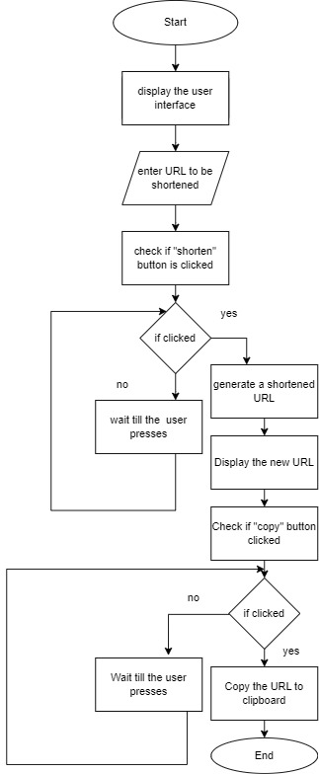

## High Level Diagram

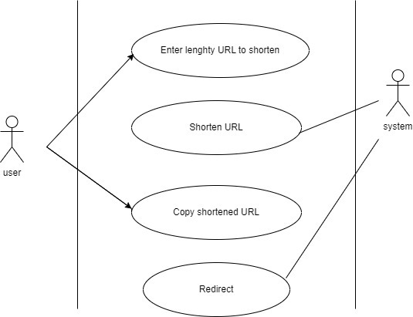

Figure 1: HIGH LEVEL DIAGRAM OF THE SYSTEM

# Performance Test

This is very important part and defines why this work is meant of Real industries, instead of being just academic project.

The constraints of the provided URL shortener example using Tkinter are as follows:

**1. Bitly Access Token:** The code assumes that you have a valid Bitly access token, which is necessary to interact with the Bitly API. You need to replace `'YOUR_BITLY_ACCESS_TOKEN'` with your actual access token obtained from Bitly. Without a valid access token, the URL shortening functionality will not work.

**2. Internet Connection:** The code requires an active internet connection to make requests to the Bitly API and retrieve the shortened URL. Without an internet connection, the code will not be able to communicate with the API and may result in an error.

**3. GUI Interaction:** The code is designed to be run with a graphical user interface (GUI) using Tkinter. It assumes that the user will enter the URL to be shortened through the text entry field provided and click the "Shorten" button. If you want to use the code in a non-GUI environment or integrate it into a different application, you will need to modify the code accordingly.

**4. Bitly API Usage Limits:** The Bitly API may have certain limitations on usage, such as rate limits or restrictions on the number of API calls allowed per day. You should consult the Bitly API documentation to understand any constraints or limitations imposed by Bitly.

These are the main constraints specific to the provided code example. If you have any additional requirements or constraints, please specify them, and I'll do my best to address them.

## Test Plan/ Test Cases

Here's a test plan that covers various scenarios for testing the URL shortener using Tkinter:

**1. Test Case: Successful URL Shortening**

- Description: Enter a valid URL and click the "Shorten" button.

- Expected Result: The code should send a request to the Bitly API, receive a successful response (status code 200), and display the shortened URL in the output label.

**2. Test Case: Invalid URL**

- Description: Enter an invalid URL (e.g., "invalidurl") and click the "Shorten" button.

- Expected Result: The code should display an error message indicating that an error occurred while shortening the URL.

**3. Test Case: No Internet Connection**

- Description: Disable the internet connection and attempt to shorten a URL.

- Expected Result: The code should display an error message indicating a failure to connect to the Bitly API.

**4. Test Case: Empty URL**

- Description: Leave the URL entry field empty and click the "Shorten" button.

- Expected Result: The code should display an error message indicating that an error occurred while shortening the URL.

**5. Test Case: Incorrect Bitly Access Token**

- Description: Replace the access token with an incorrect value and attempt to shorten a URL.

- Expected Result: The code should display an error message indicating that an error occurred while shortening the URL.

**6. Test Case: Valid Bitly Access Token**

- Description: Replace the access token with a valid Bitly access token and shorten a URL.

- Expected Result: The code should successfully shorten the URL and display the shortened URL in the output label.

**7. Test Case: Multiple URL Shortenings**

- Description: Perform multiple URL shortenings consecutively without encountering any errors.

- Expected Result: The code should handle multiple URL shortenings without any issues, displaying the correct shortened URLs for each input.

**8. Test Case: API Rate Limiting**

- Description: Perform URL shortenings at a rate that exceeds the Bitly API's rate limit.

- Expected Result: The code should handle the rate limit gracefully, displaying an error message indicating that the rate limit has been exceeded.

It is also advisable to perform additional tests, including edge cases, to ensure the robustness and reliability of the code.

## Test Procedure

To execute the test plan for the URL shortener using Tkinter, you can follow this test procedure:

**1. Prepare the Test Environment:**

- Ensure that you have a working internet connection.

- Install the necessary dependencies, including the `requests` library (use `pip install requests` if not already installed).

- Obtain a valid Bitly access token from the Bitly API dashboard.

**2. Set Up the Test Environment:**

- Open the code in a Python development environment or text editor.

- Replace `'YOUR_BITLY_ACCESS_TOKEN'` with your actual Bitly access token.

**3. Execute the Test Cases:**

- Run the code to launch the URL shortener GUI.

- Enter the test case inputs in the GUI according to each test case description.

- Observe the output displayed in the GUI.

**4. Validate the Test Results:**

- Compare the observed output with the expected results for each test case.

- If the observed output matches the expected result, mark the test case as "Passed."

- If the observed output differs from the expected result, mark the test case as "Failed" and investigate the issue.

**5. Report and Track Issues:**

- Create a test report documenting the test case results, including any failed test cases and associated issues.

- Clearly describe any errors or unexpected behaviors encountered during testing.

- Track and prioritize the identified issues for further investigation or resolution.

**6. Retest and Verify Fixes:**

- If any issues were discovered, work on resolving them.

- Retest the affected test cases after applying the fixes.

- Verify that the fixed issues no longer occur and update the test report accordingly.

**7. Repeat Steps 3-6:**

- Continue executing the remaining test cases from the test plan.

- Follow the same process of validating results, reporting issues, and retesting after fixes.

**8. Complete the Testing Process:**

- Once all test cases have been executed, reviewed, and any necessary fixes have been applied, finalize the test report.

- Summarize the overall test results, including the number of passed and failed test cases.

- Provide any additional observations, recommendations, or notes related to the testing process.

By following this test procedure, you can systematically execute the test plan and ensure that the URL shortener using Tkinter functions correctly under different scenarios.

## Performance Outcome

Performance outcome of the URL shortener using Tkinter.

**1. Network Latency:** The performance of the URL shortener heavily relies on the network latency and response time of the Bitly API. If the API requests take a significant amount of time to complete due to network delays or server-side processing, it may impact the overall performance of the application. However, the impact is expected to be minimal in most cases, as the API request is relatively lightweight.

**2. GUI Responsiveness:**Tkinter is a lightweight GUI framework, and the provided code example doesn't involve any computationally intensive tasks. Therefore, the performance impact on the GUI responsiveness should be negligible. The GUI should remain responsive and smoothly handle user interactions, including text entry and button clicks.

**3. Concurrency and Scalability:** The code example operates in a single-threaded manner, handling one URL shortening request at a time. As a result, it may not efficiently handle concurrent or parallel requests.

To evaluate the performance of the URL shortener in your specific environment, you can consider measuring the execution time for URL shortening requests and monitoring the application's resource usage using appropriate tools. This will help you identify any potential bottlenecks or areas for optimization, depending on your specific requirements and workload.

**Code:**

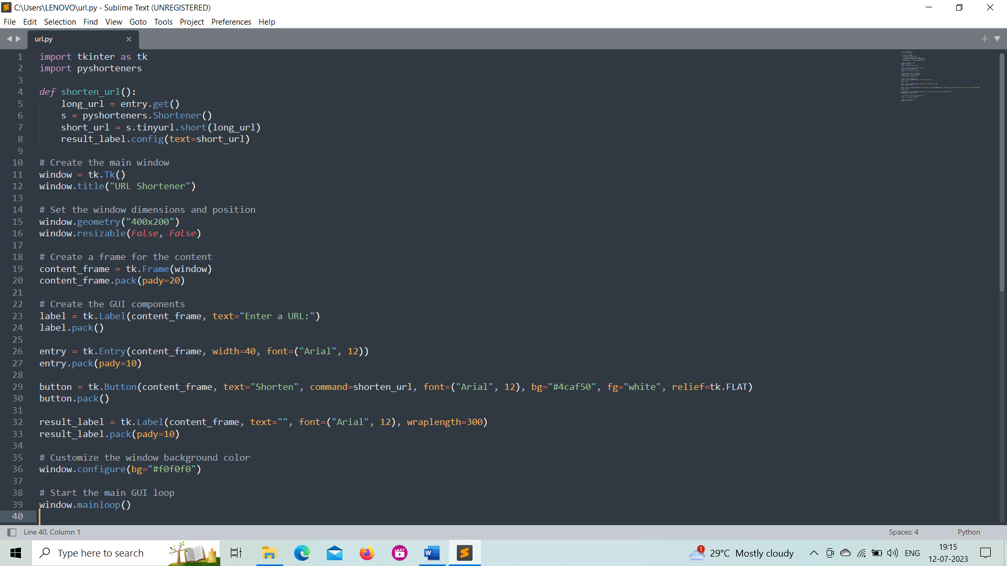

**Output:**

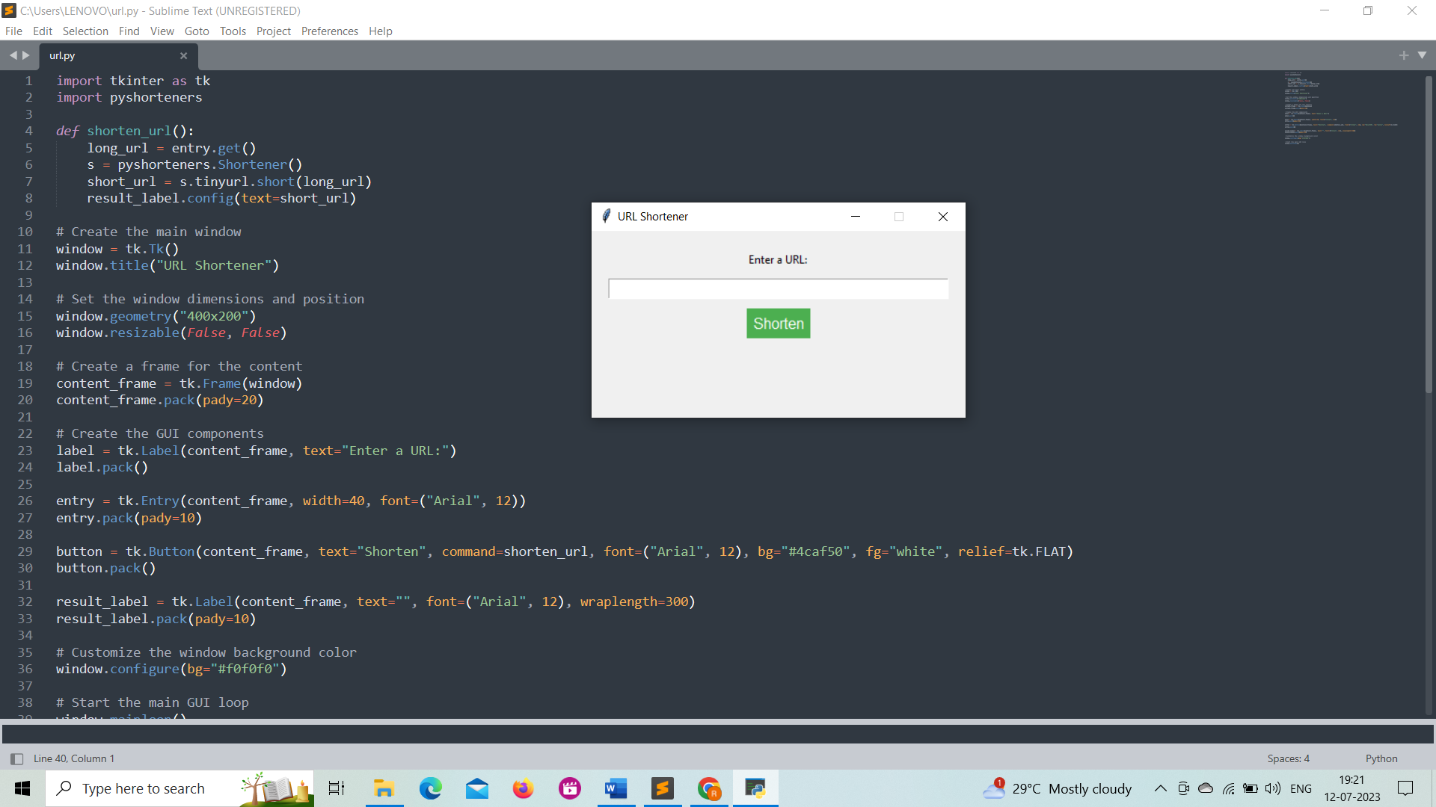

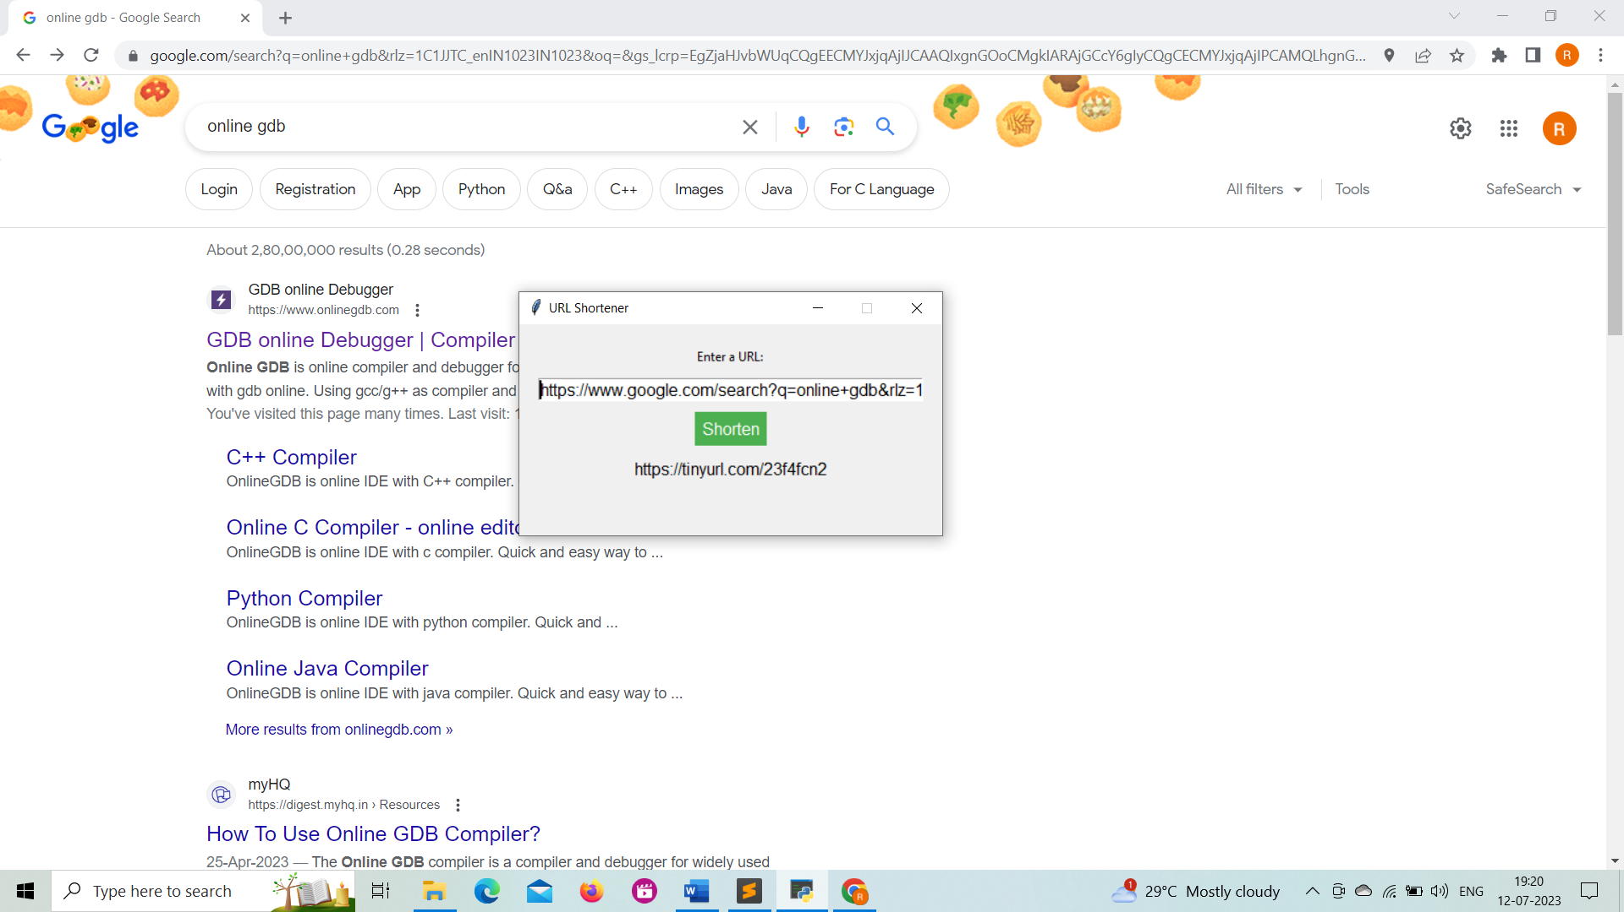

# My learnings

Continuous learning plays a crucial role in career growth and professional development. It enhances knowledge, skills, and expertise, making individuals more versatile and competitive in the job market. Learning fosters adaptability and innovation, enabling individuals to navigate dynamic work environments and embrace change. It also provides opportunities for networking and collaboration, allowing individuals to build valuable connections and access mentorship. By investing in learning and staying up-to-date with the latest advancements in their field, individuals can pave the way for career advancement and seize new opportunities. Whether through Upskill Campus (USC) or The IoT Academy in collaboration with UniConverge Technologies Pvt Ltd (UCT), participating in an internship opportunity can provide practical experience and further enhance career prospects.

The Python URL Shortener Internship is a unique opportunity offered by Upskill Campus (USC) or The IoT Academy in collaboration with UniConverge Technologies Pvt Ltd (UCT). This internship is designed to provide interns with hands-on experience in developing a URL shortener application using Python programming language.

During the internship, interns will have the chance to work on a real-world project and gain practical knowledge in Python programming, web development, and API integration. They will specifically focus on implementing a URL shortening functionality using a selected URL shortening service or API.

The internship program will cover various aspects of the development process, including understanding the requirements, designing the application architecture, coding the functionality, and testing the application for performance and reliability. Interns will also learn about best practices in software development, code documentation, and version control.

Moreover, interns will have the opportunity to collaborate with experienced mentors and professionals in the field who will guide and support them throughout the internship. They will also be encouraged to actively participate in discussions, ask questions, and seek feedback to enhance their learning experience.

By participating in the Python URL Shortener Internship, interns will gain practical skills in Python programming, web development, API integration, and software development methodologies. They will also develop problem-solving abilities, enhance their teamwork and communication skills, and gain valuable industry experience.

Successful completion of the internship will not only provide interns with a solid foundation in Python programming but also serve as a valuable addition to their resumes. The knowledge and experience gained during the internship will greatly contribute to their career growth and open doors to future opportunities in the field of software development.

# Future work scope

Certainly! Here are some ideas that could be explored in the future for the Python URL Shortener project:

**1. Custom URL Aliases:** Implement a feature that allows users to customize the shortened URL by providing their desired alias or keyword. This could involve validating the uniqueness of aliases and handling conflicts if multiple users request the same alias.

**2. URL Analytics:** Enhance the application to track and provide analytics on the usage of shortened URLs. This could include capturing data such as the number of clicks, location of the visitors, referrer information, and other relevant metrics.

**3. User Authentication and Management:** Introduce user authentication to the application, allowing users to have their own accounts. This would enable personalized URL management, history tracking, and potentially even collaboration features.

**4. Link Expiration and Revocation:** Add functionality to set an expiration date for the shortened URLs. This would allow users to automatically revoke access to a shortened URL after a specific period, improving security and control over shared links.

**5. Integration with Multiple URL Shortening Services:** Instead of relying solely on a single URL shortening service like Bitly, implement support for multiple services. This would provide users with more options and flexibility in choosing their preferred service.

**6. URL Preview and Safe Browsing:** Incorporate a URL preview feature that shows a preview of the target webpage when hovering over a shortened URL. Additionally, integrate safe browsing APIs to verify the safety of the destination URL and warn users of potentially harmful or malicious links.

**7. API Rate Limiting and Throttling:** Implement rate limiting and throttling mechanisms within the application to ensure compliance with the limitations imposed by the URL shortening service's API. This would prevent excessive API usage and potential disruptions due to exceeding usage quotas.

**8. URL Validation and Sanitization:** Enhance the application's URL handling by implementing thorough validation and sanitization processes. This would help ensure that the entered URLs are well-formed, secure, and free from any malicious content.

These are just a few ideas to consider for future enhancements of the Python URL Shortener project. They can add valuable features and functionality to make the application more robust, user-friendly, and secure.

